ELEC 2110

Electric Circuit Analysis

Gabriel Emerson

Jake Bryson

September 17, 2019

Section 002

Recitation & MultiSim: Thevenin’s and Norton’s Theorem

Introduction

The student will work to solve problems related to Thevenin’s and Norton’s Theorem. Given circuits, solve using Thevenin’s and Norton’s. Theorem, then verify using Multisim.

Exercise 1

Use Thevenin’s theorem to find Vo and use MultiSim to verify the answer.

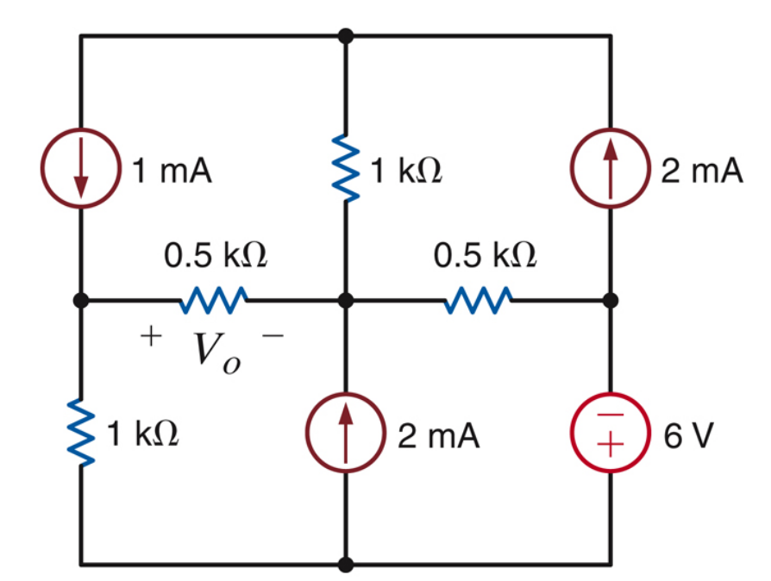

(1)

Circuit 1

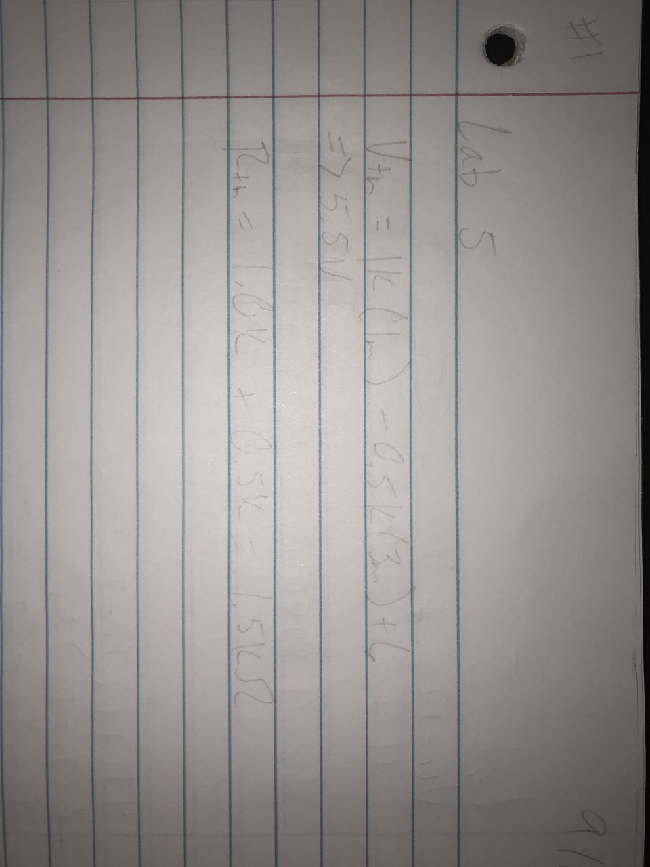

Equations for exercise 1 circuit 1 (2)

Summary Table

|  |  |
| --- | --- |
| Vth | 5.5V |
| Rth | 1.5k Ohm |
| Vo | 1.375V |

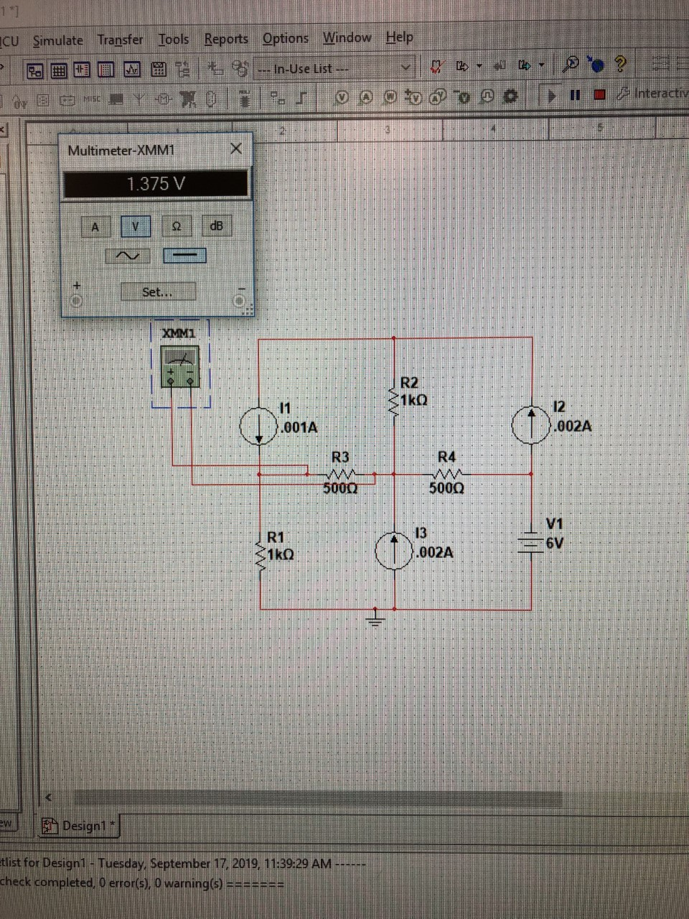

(3)

Verify Vo

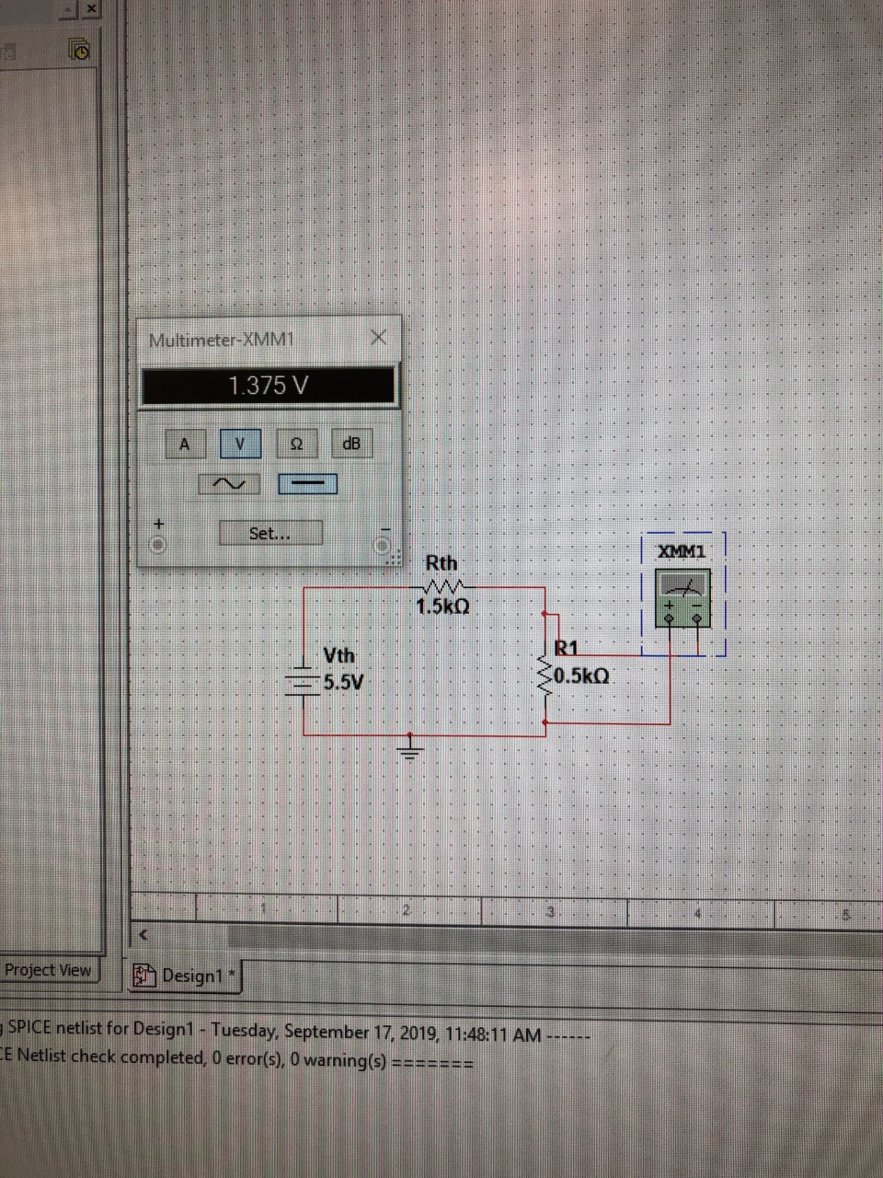

(4)

Verify using Thevenin’s Circuit

Exercise 2

Given a new circuit, find RL and use it to find maximum Power (Pmax) for RL. Then plot RL and Pmax.

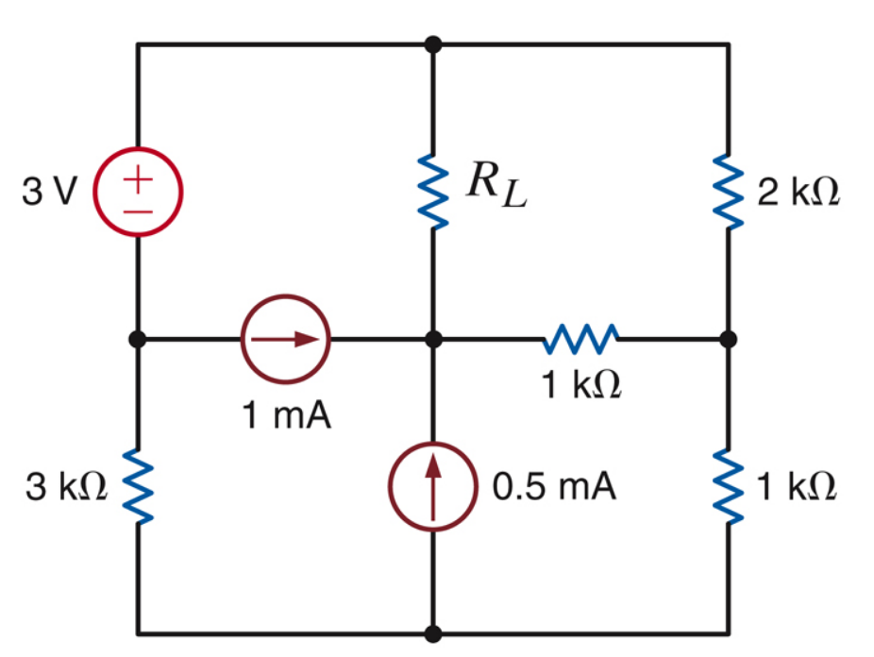

Circuit 2 (5)

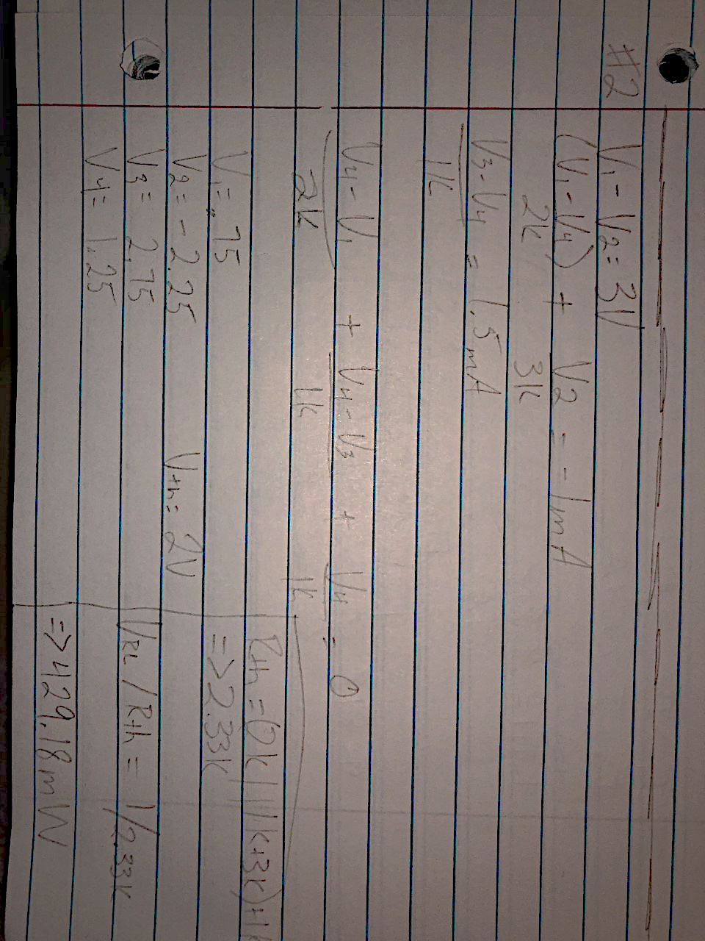

(6)

Equations for exercise 2 circuit 2

Summary Table

|  |  |
| --- | --- |
| V1 | 0.75V |
| V2 | -2.25V |
| V3 | 2.75V |
| V4 | 1.25V |
| Vth | 2.00V |
| Rth | 2.33k Ohm |
| VRL/Rth= Pmax | = 1/(2.33k)= 429.18mW |

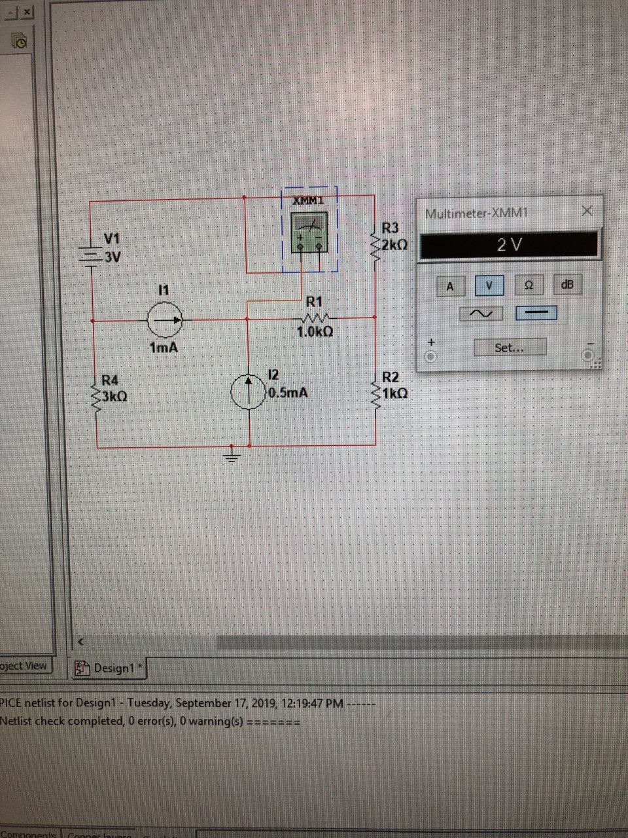

(7)

Verify Vth

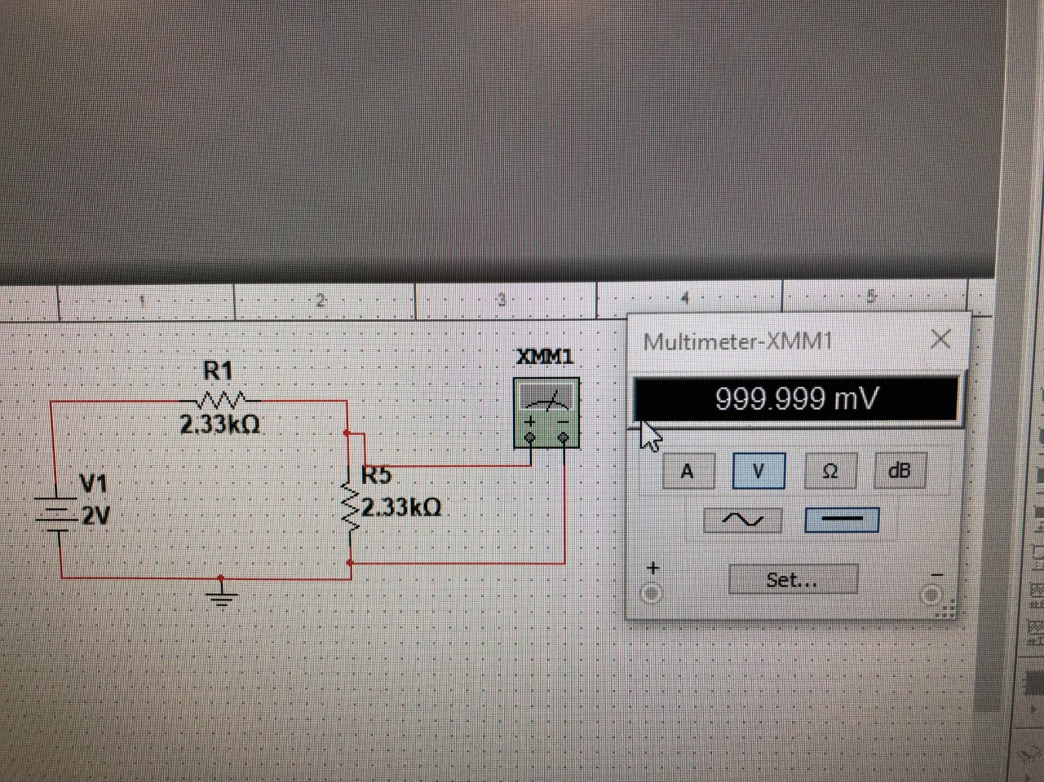

(8)

Verify using Thevenin’s Circuit

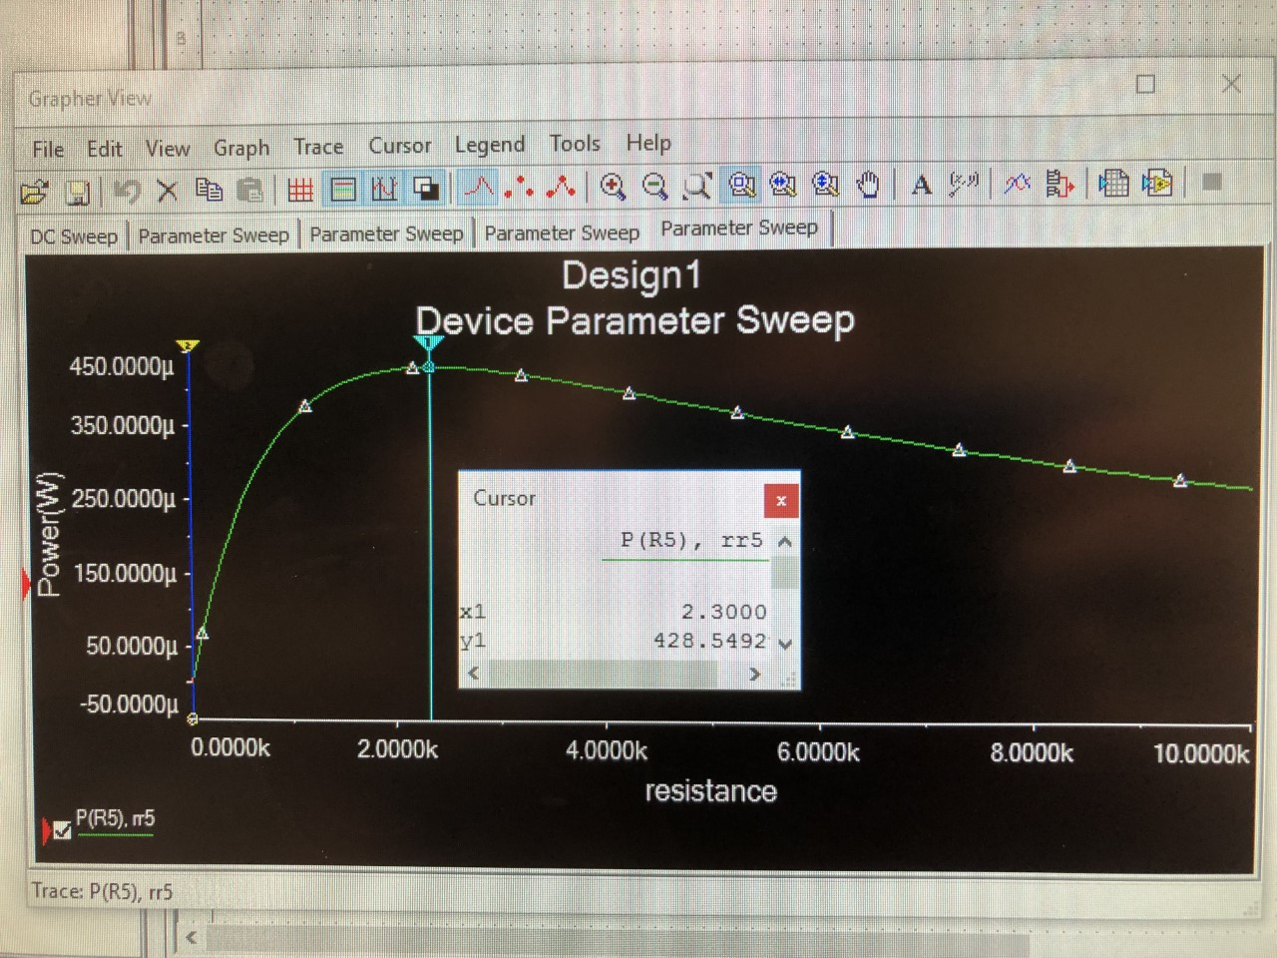

(9)

Parameter sweep for exercise 2 (very sorry it is black)

Exercise 3

Use Thevenin’s Theorem to solve for Vx in circuit 3. Use MultiSim to verify the answer.

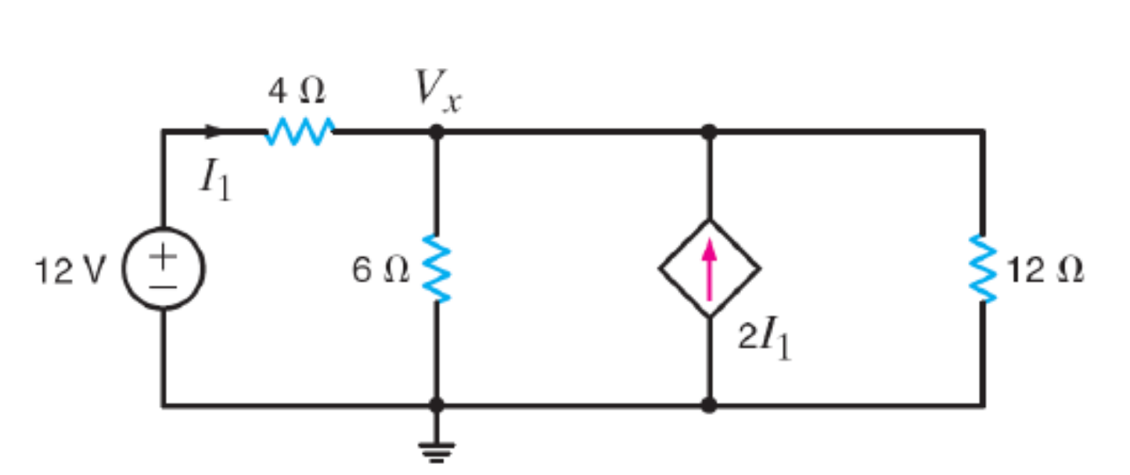

Circuit 3 (10)

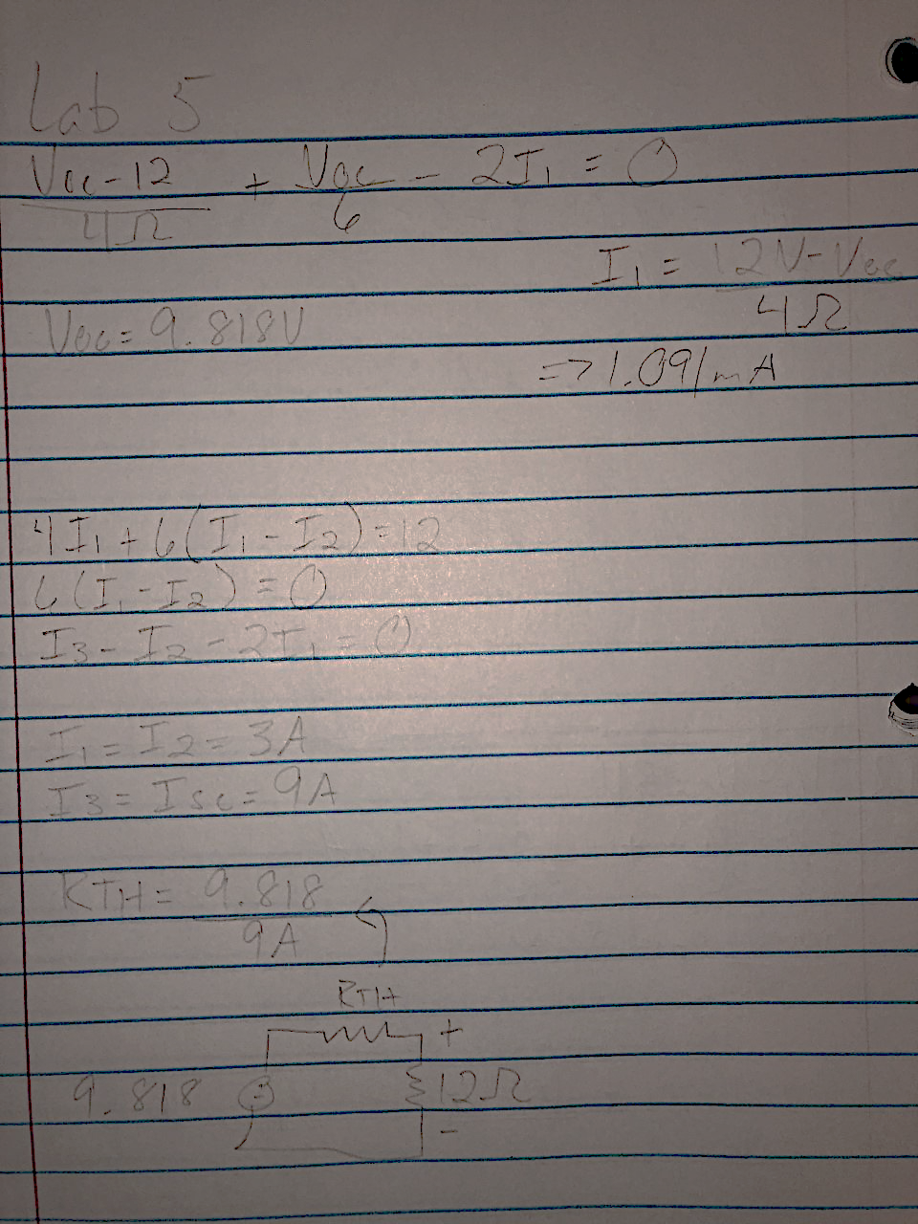

(11)

Equations for Exercise 3 Circuit 3

Summary Table

|  |  |
| --- | --- |
| Voc | 9.818V |
| Isc | 9A |
| Rth= Voc/Isc | = 9.818/9 = 1.091Ohms |

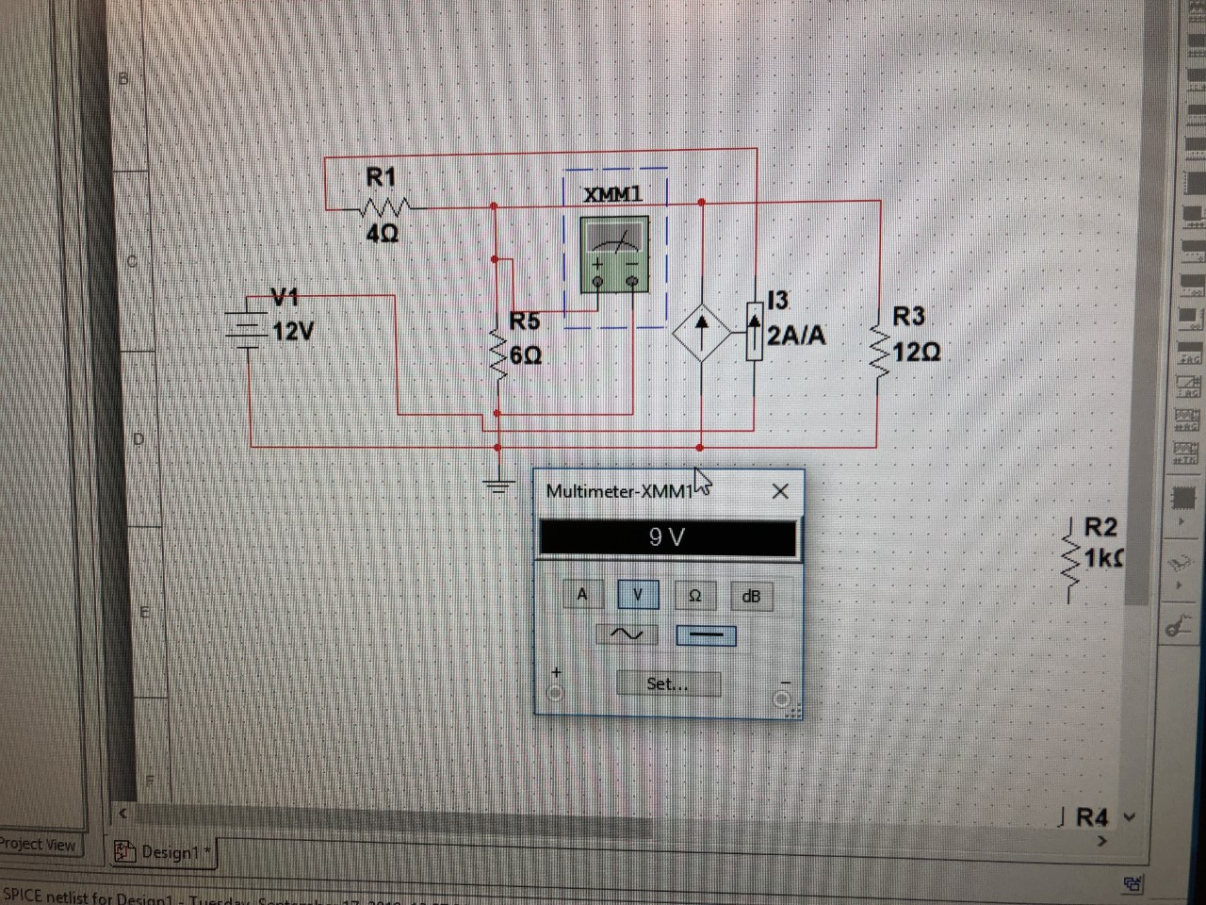

(12)

Verify Vx

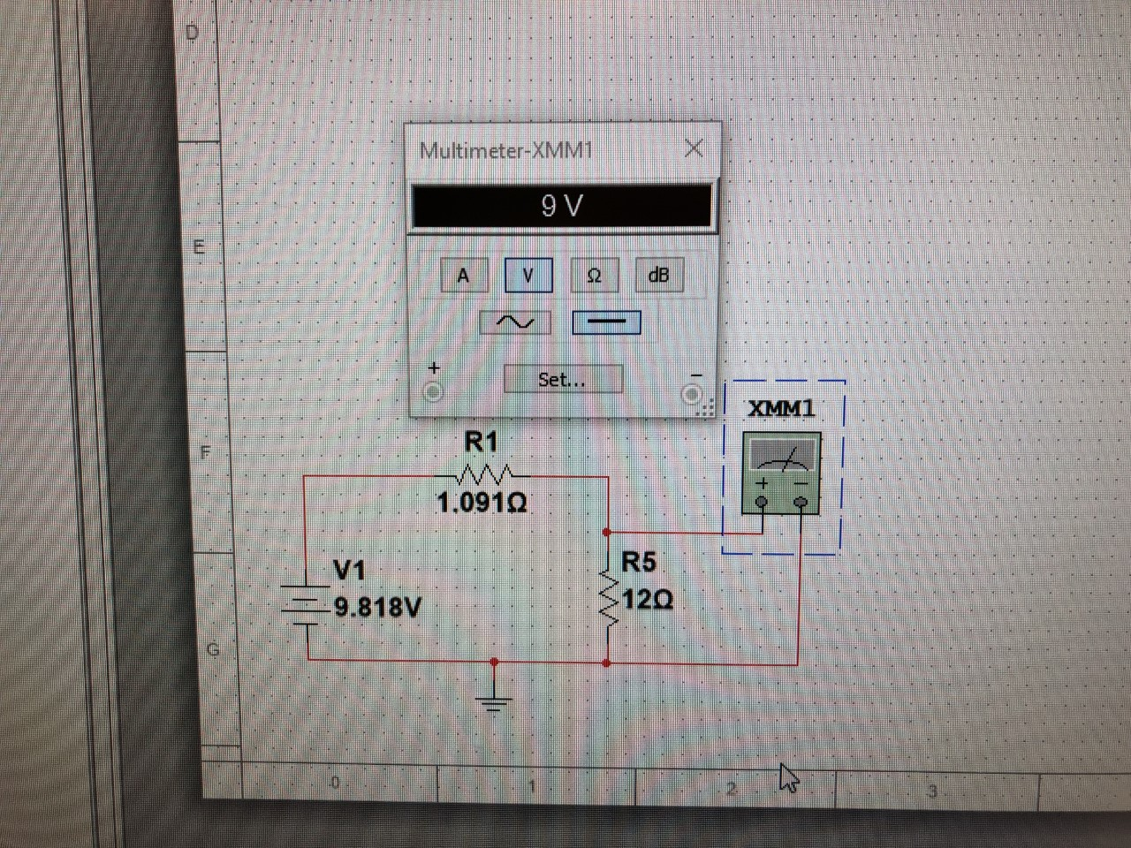

(13)

Verify using Thevenin’s Circuit

Exercise 4

Build the Thevenin circuit between nodes A and B for the given circuit. Then build it in MultiSim and verify your answer using the Ohmmeter.

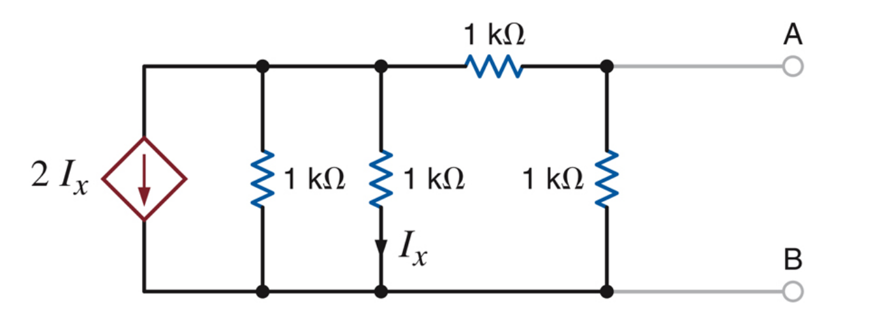

(14)

Circuit 4

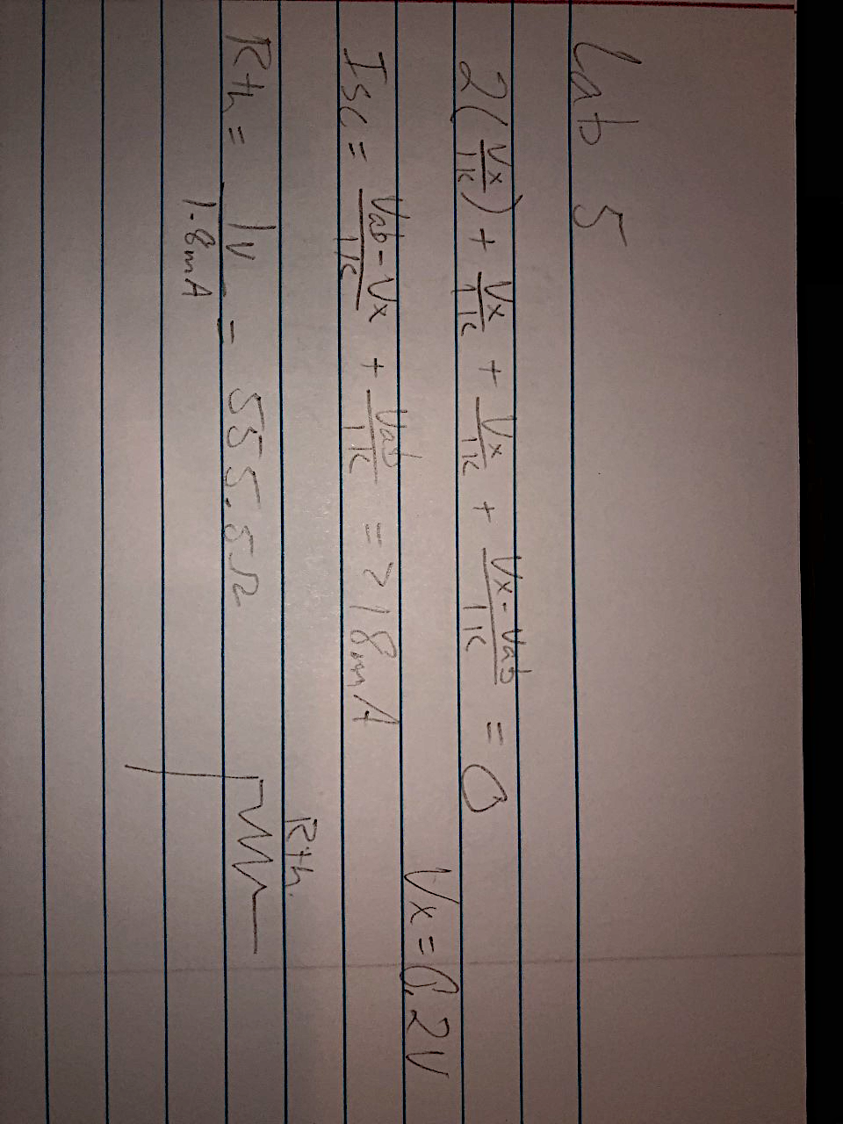

(15)

Equations for Exercise 4 Circuit 4

Summary Table

|  |  |
| --- | --- |
| Vx | 0.2V |
| Isc | 1.8mA |
| Rth | 555.5 Ohm |

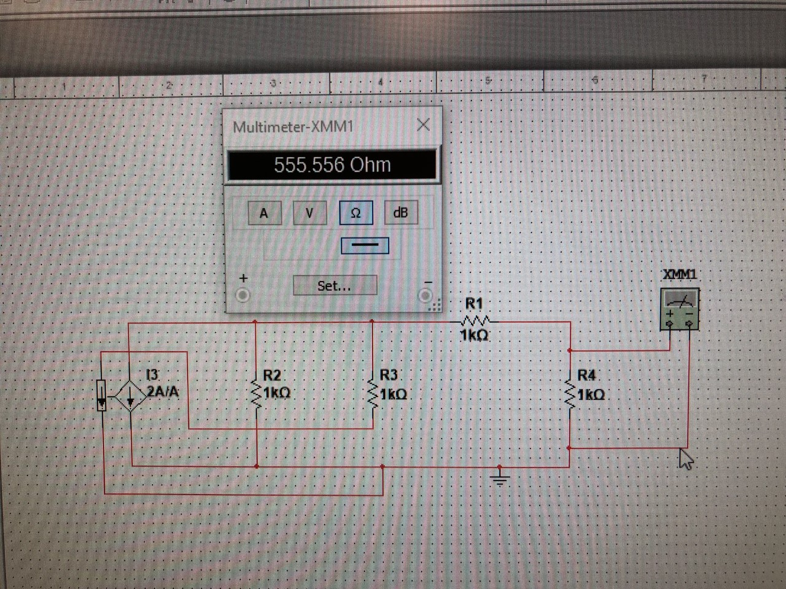

(16)

Verify Rth

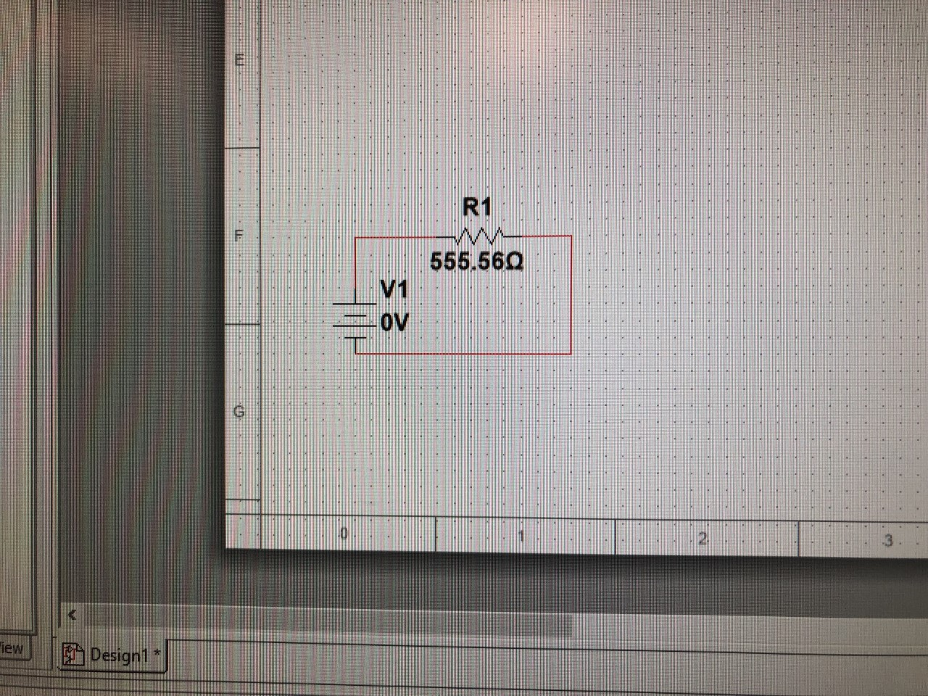

(17)

Verify using Thevenin Circuit

Exercise 5

Given a new circuit, find RL and Pmax, and verify using MultiSim. Then plot resistance (RL) / Power (Pmax).

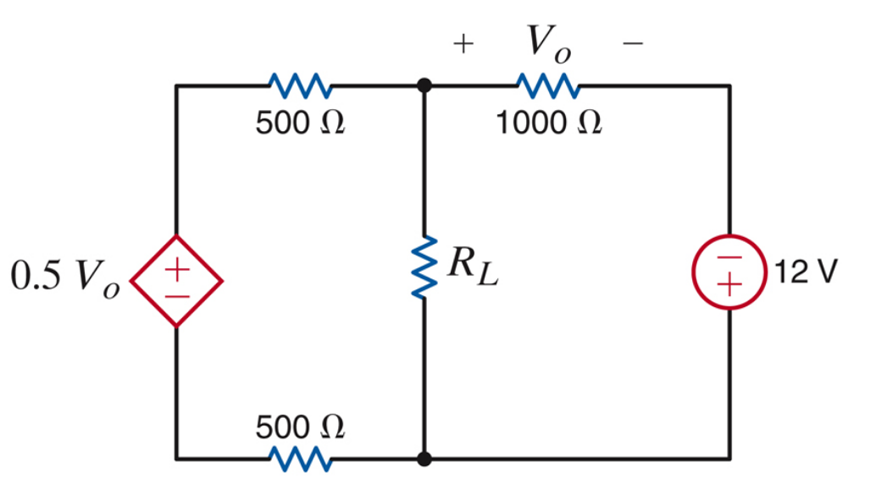

(18)

Circuit 5

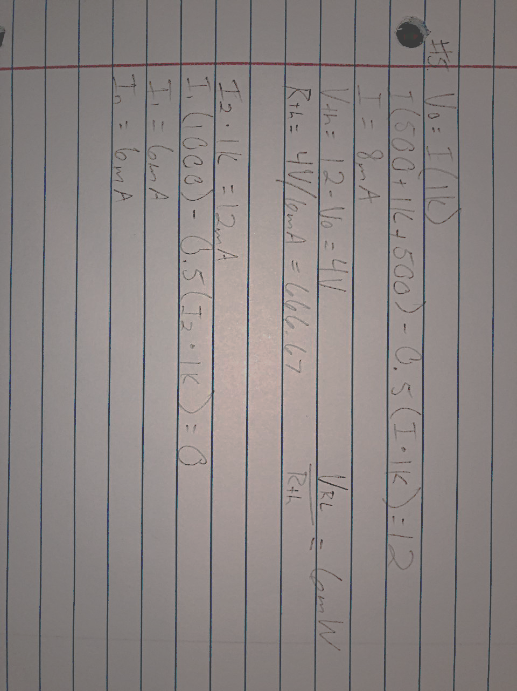

(19)

Equations for Exercise 5 Circuit 5

Summary Table

|  |  |
| --- | --- |
| I | 8mA |
| I1 | 6mA |
| I2 | 12mA |
| In | 6mA |
| Vth | 4V |
| Rth | 666.67 Ohm |
| Pmax | 6mW |

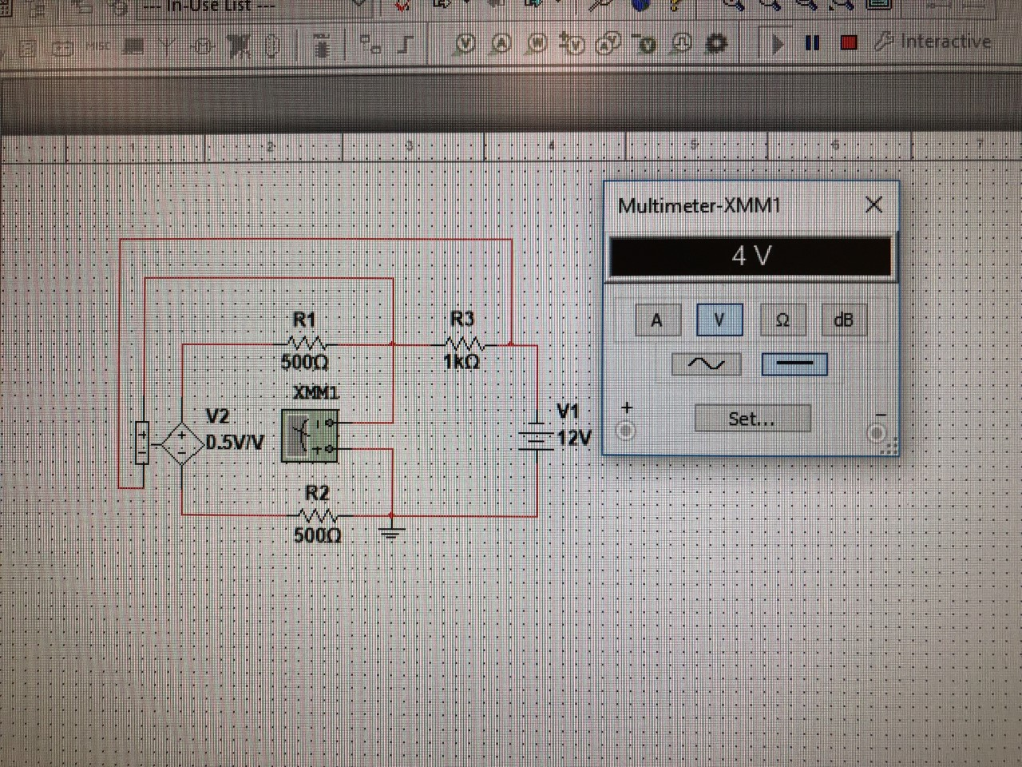

(20)

Verify Vth

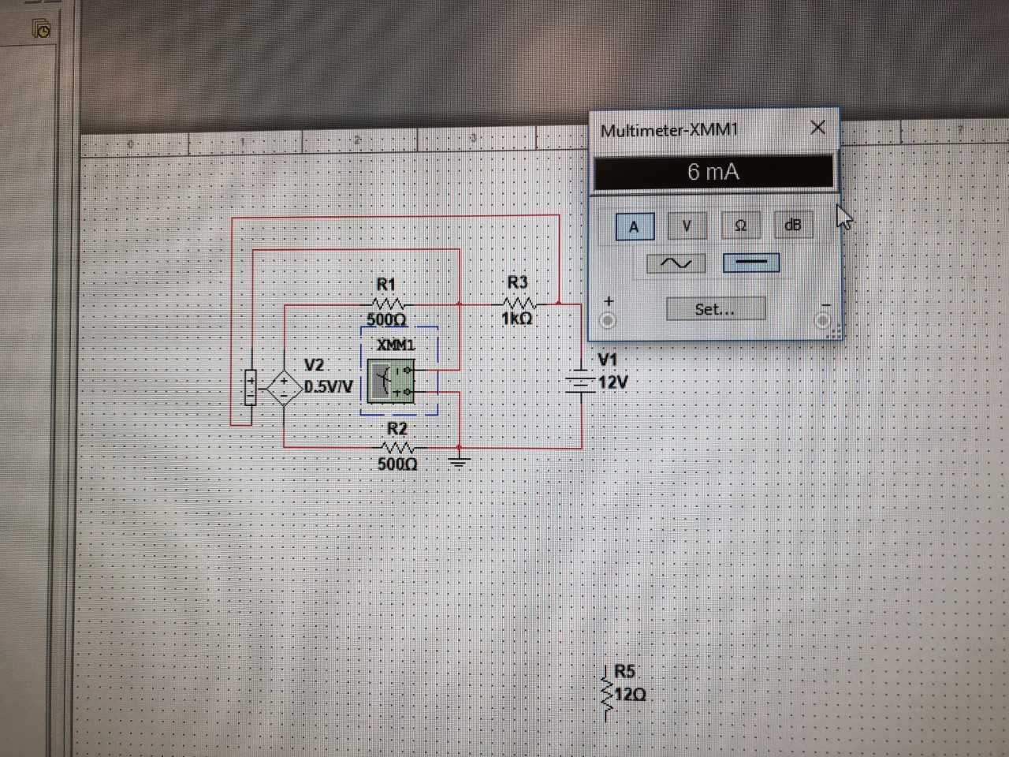

(21)

Verify Current

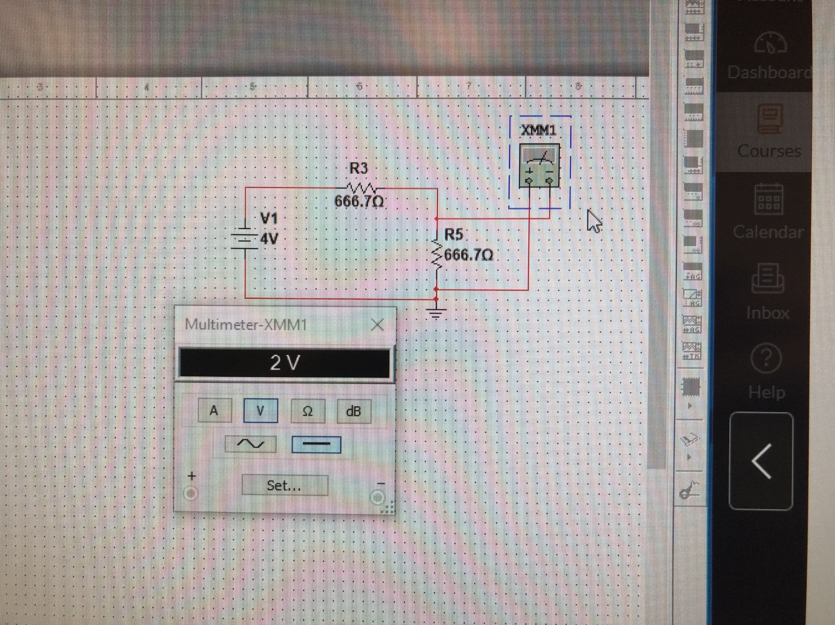

(22)

Verify V across Rth

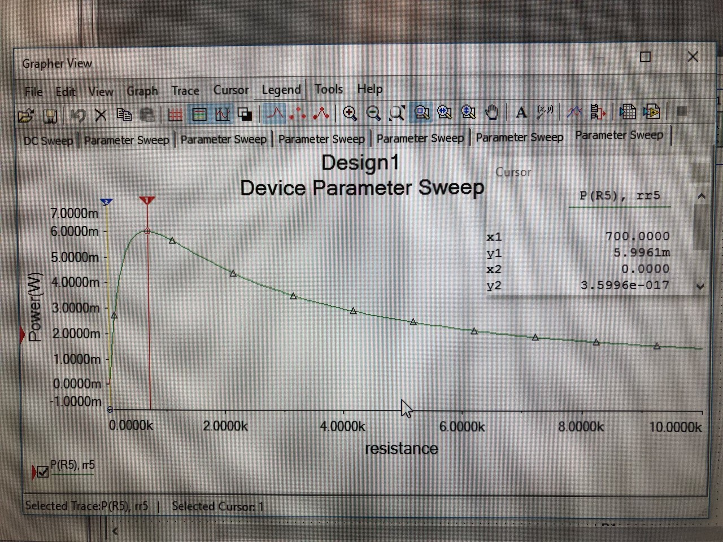

(23)

Parameter sweep for Exercise 5

Conclusion

Using Norton’s and Thevenin’s Theorem makes solving certain circuits much easier. Lab 5 is a crucial beginning for the student to understand there are many ways to solve circuits, and depending on the circuit, certain ways are easier than others. Thevenin’s Circuits play a big role in Electrical Engineering and it is very important to understand its strengths and weaknesses.

Bibliography

1. Circuit 1 given for exercise 1
2. Hand-written equations for exercise 1, circuit 1
3. Verify Vo using MultiSim for exercise 1, circuit 1
4. Verify using Thevenin Circuit for exercise 1, circuit 1
5. Circuit 2 given for exercise 2
6. Hand-written equations for exercise 2, circuit 2
7. Verify Vth using MultiSim for exercise 2, circuit 2
8. Verify using Thevenin Circuit for exercise 2, circuit 2
9. Parameter sweep of Resistance and Power for exercise 2, circuit 2
10. Circuit 3 given for exercise 3
11. Hand-written equations for exercise 3, circuit 3
12. Verify Vx using MultiSim for exercise 3, circuit 3
13. Verify using Thevenin Circuit for exercise 3, circuit 3
14. Circuit 4 given for exercise 4
15. Hand-written equations for exercise 4, circuit 4
16. Verify Rth using MultiSim for exercise 4, circuit 4
17. Verify using Thevenin Circuit for exercise 4, circuit 4
18. Circuit 5 given for exercise 5
19. Hand-written equations for exercise 5, circuit 5
20. Verify Vth using MultiSim for exercise 5, circuit 5
21. Verify Current using MultiSim for exercise 5, circuit 5
22. Verify using Thevenin Circuit for exercise 5, circuit 5
23. Parameter sweep of Resistance and Power for exercise 5, circuit 5